WEB TECHNOLOGY

DOCUMENTATIONS

JOB PORTAL

A job portal, also known as a job board or job website, is an online platform where employers and recruiters can post job vacancies and where job seekers can search for and apply to those vacancies.

PURPOSES OF JOB PORTAL;

There are many purposes of job portal include the following;

1. **Connect Job Seekers with Employers**: The primary purpose of a job portal is to facilitate the connection between job seekers and employers by providing a platform where both parties can interact.
2. **Job Discovery**: Job portals allow job seekers to search for job openings based on various criteria such as location, industry, job title, and experience level.
3. **Job Application Management**: Job portals provide tools for job seekers to submit their resumes and cover letters electronically to apply for job vacancies posted by employers.
4. **Resume Posting**: Job seekers can create profiles and upload their resumes to job portals, making it easier for employers to find and contact them for potential job opportunities.
5. **Job Alerts and Notifications**: Job portals often offer job alert features where users can set up criteria-based notifications to receive updates about new job postings matching their preferences.
6. **Career Guidance and Resources**: Some job portals provide resources such as career advice articles, resume writing tips, interview preparation guides, and skill development courses to help job seekers improve their chances of securing employment.
7. **Networking Opportunities**: Job portals with social networking features enable job seekers to connect with recruiters, industry professionals, and other job seekers to expand their professional network and explore career opportunities.
8. **Employer Branding and Recruitment Marketing**: For employers, job portals serve as platforms to showcase their employer brand, promote their job openings, and attract top talent through targeted recruitment marketing efforts.

display insert confirmation message to the user, he has choice to confirm insert then insert data in table or cancel then back to applications.php

DATABASE

Database entitie

**Application database structure**

Here all job seekers make register in order to be keep their records

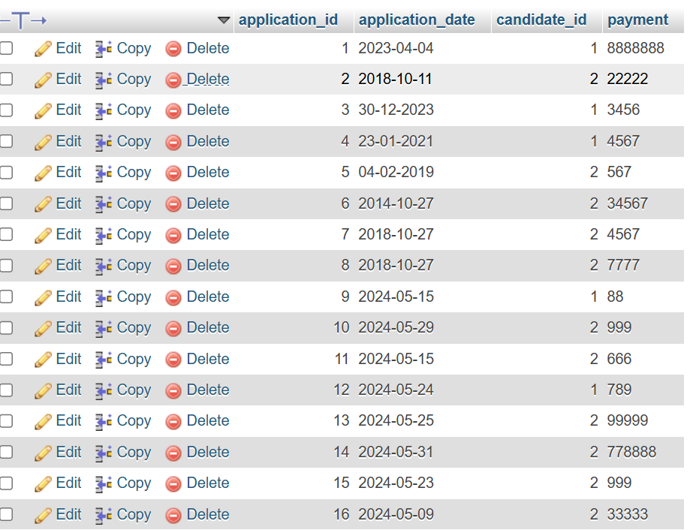

**2 candidates database stricture**

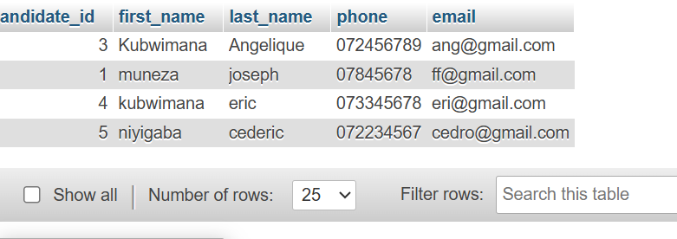

**3jobs database stracture:**here you see all postions available in order to make application

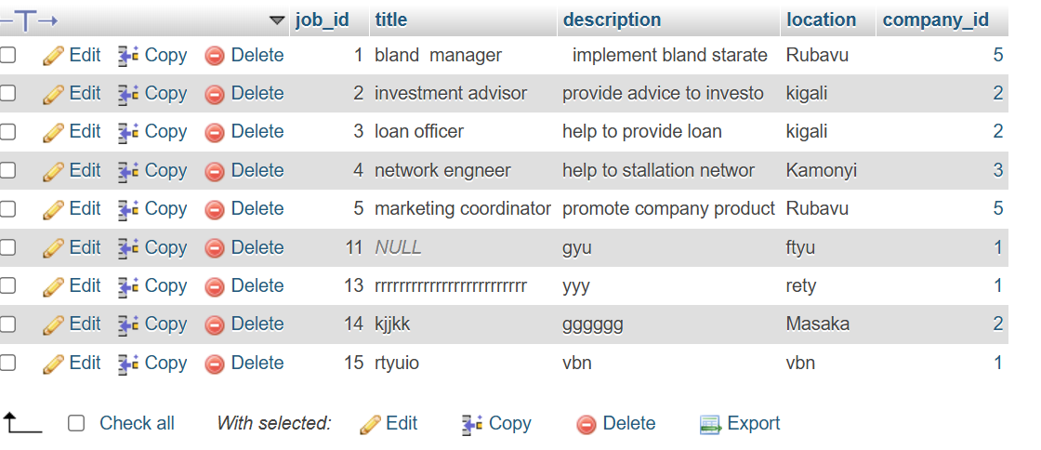

**4.users database stracture**

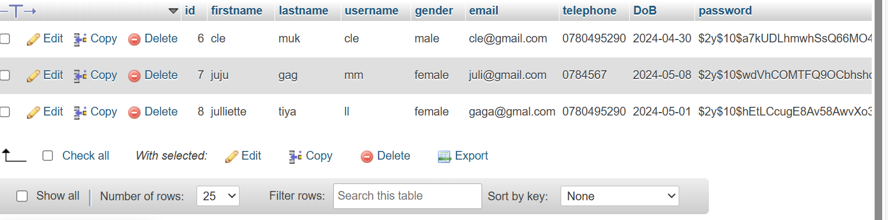

**5.Resumes database stracture**

*You provide references and what you konw*

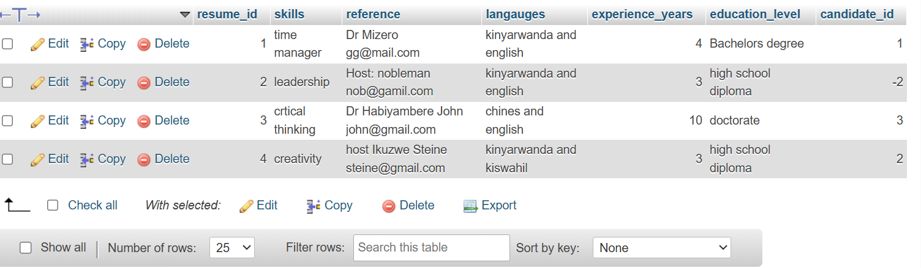

**6. skills database stracture**

You provide skill you know and certificate you have

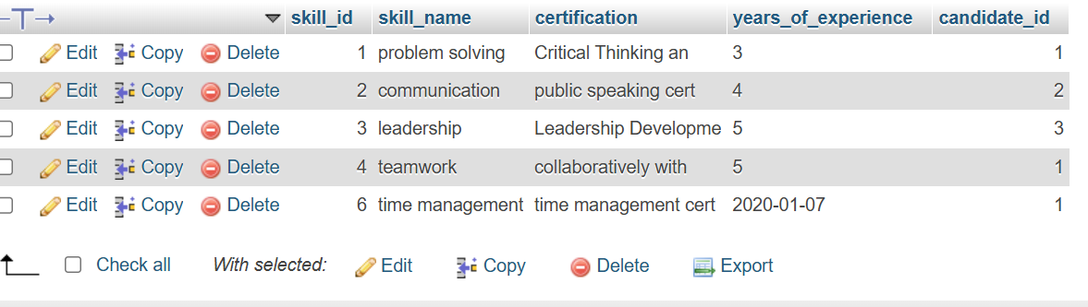

**7.salaryranges database stracture**

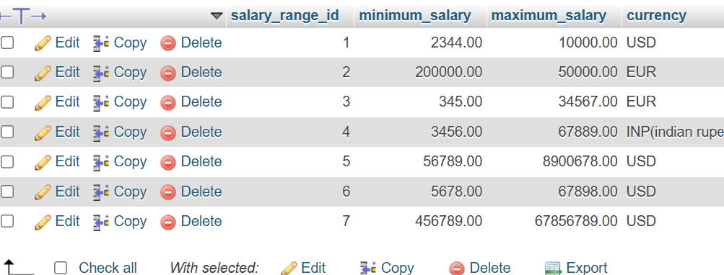

**8 . experiences database stracture**

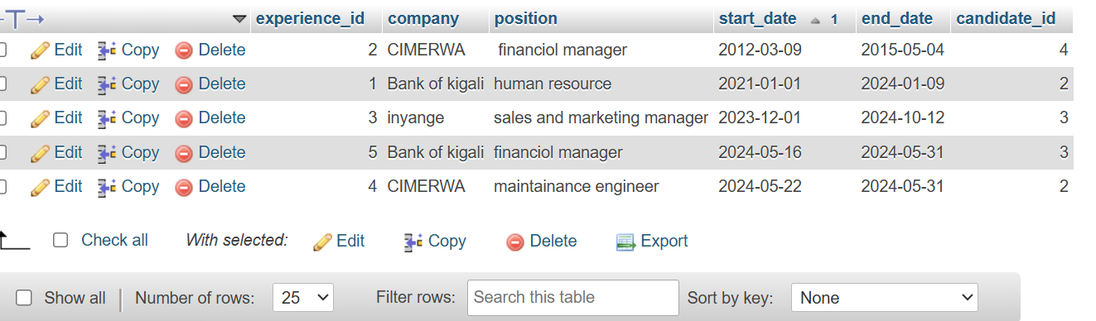

1. **Candidates database stracture**

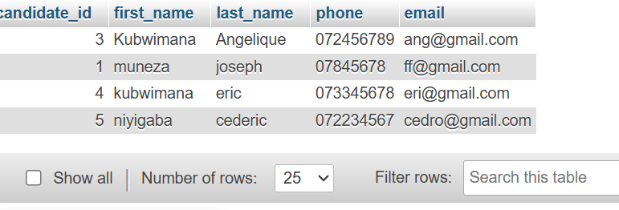

1. **Company database stracture**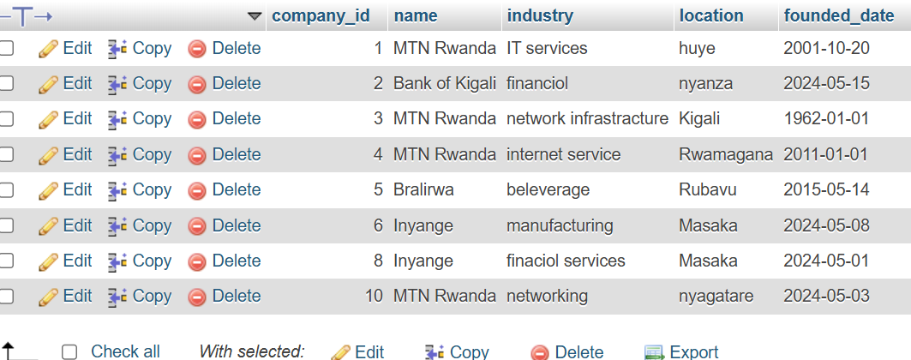
2. **Education database stracture2**

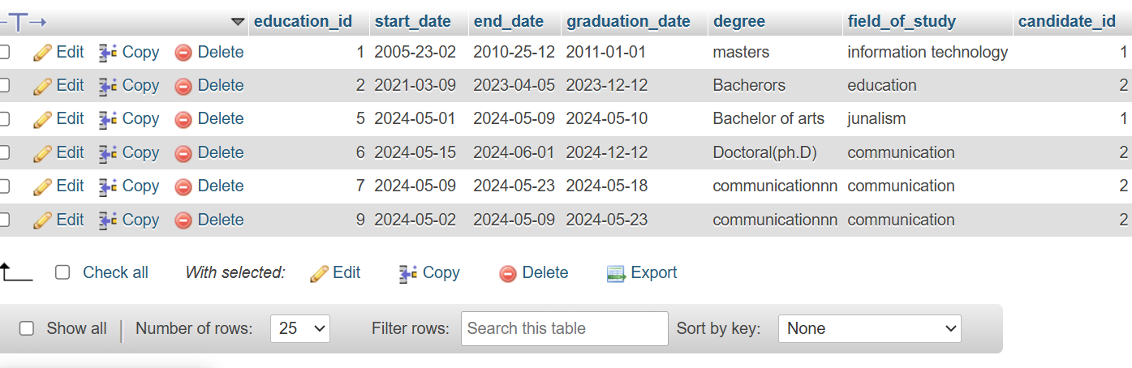

2 WEB TECHNOLOGY

1 in this chapter I will be describe how job portal uised to create the analysed web , under this chapter I will under go detail of how everything will function together with database that have been discuss above .

TOOLS UDES TO DEVELOPE THIS SYSTEM

Xammp and sublime

Index. php

Welcome to our website if you have account you login and if you does not you make registering

**Login form**

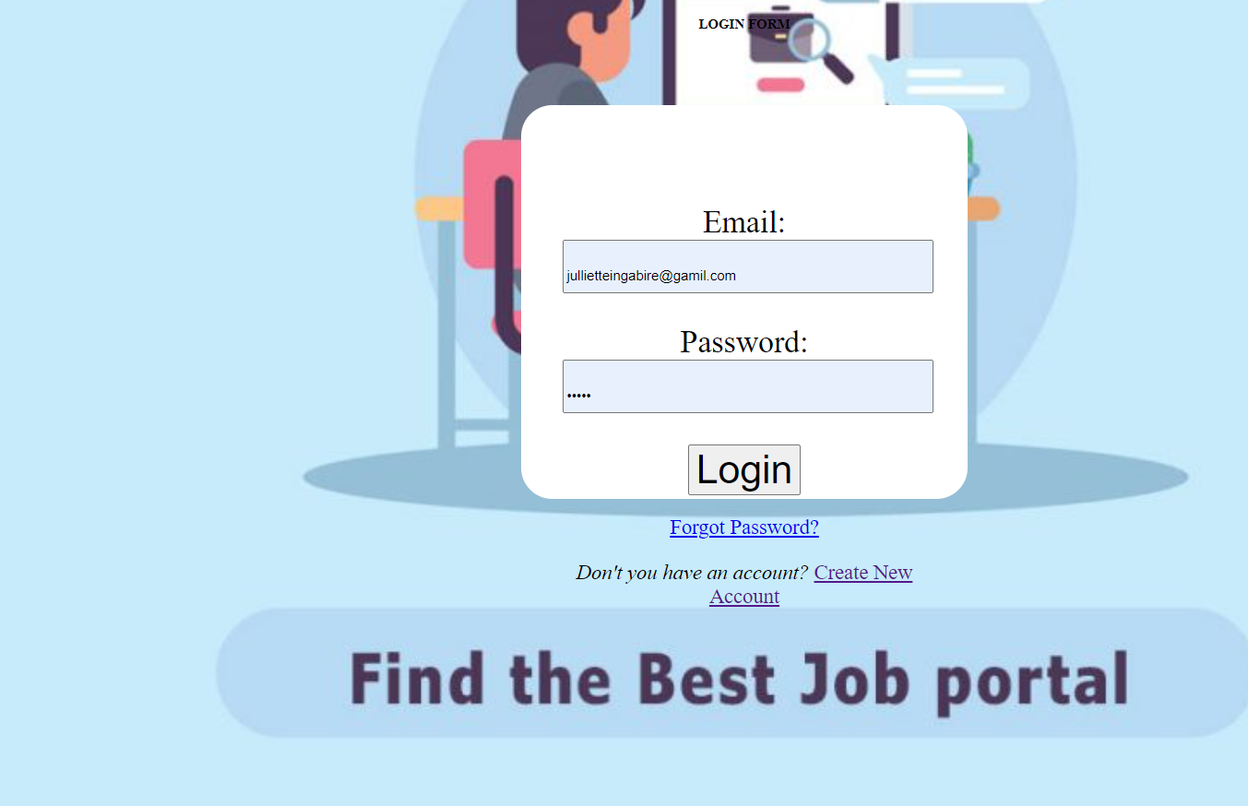

**Registering form**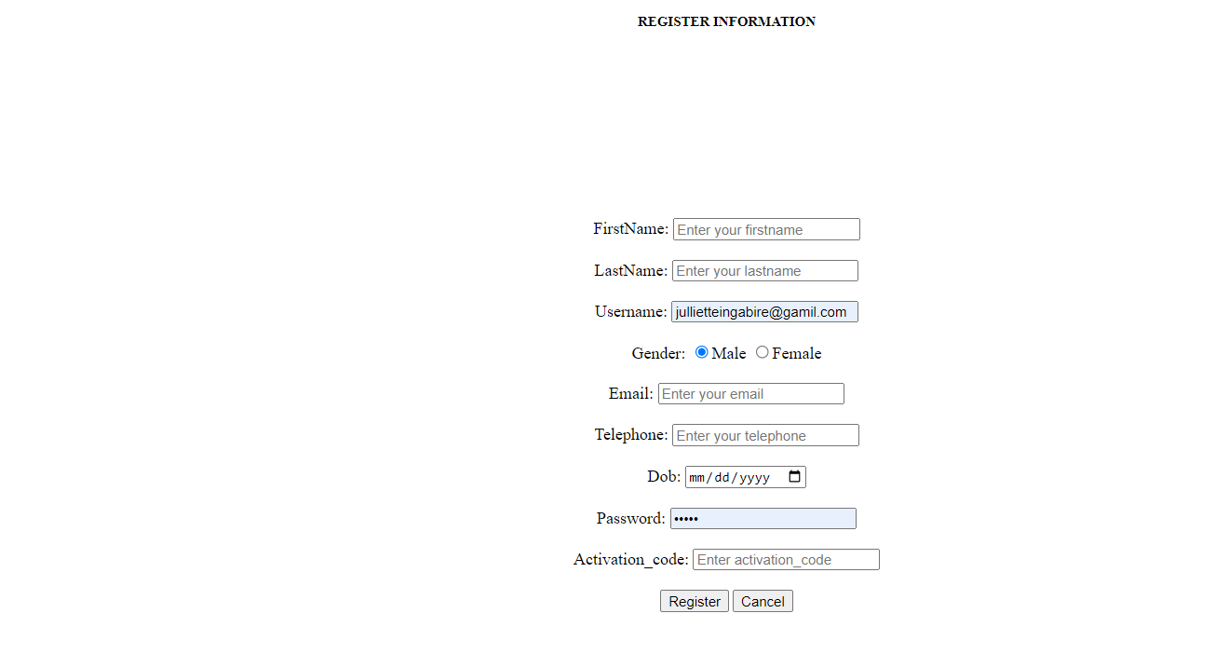

**3.Home ,about,contact , MENU,settings**

**Home ; when you click on home you see welcome word**

**About; when you click about ,you see all information about our website**

**MENU; in menu you see all tables include in our website**

**Setting; when you click on setting you log in , logout and regiuster**

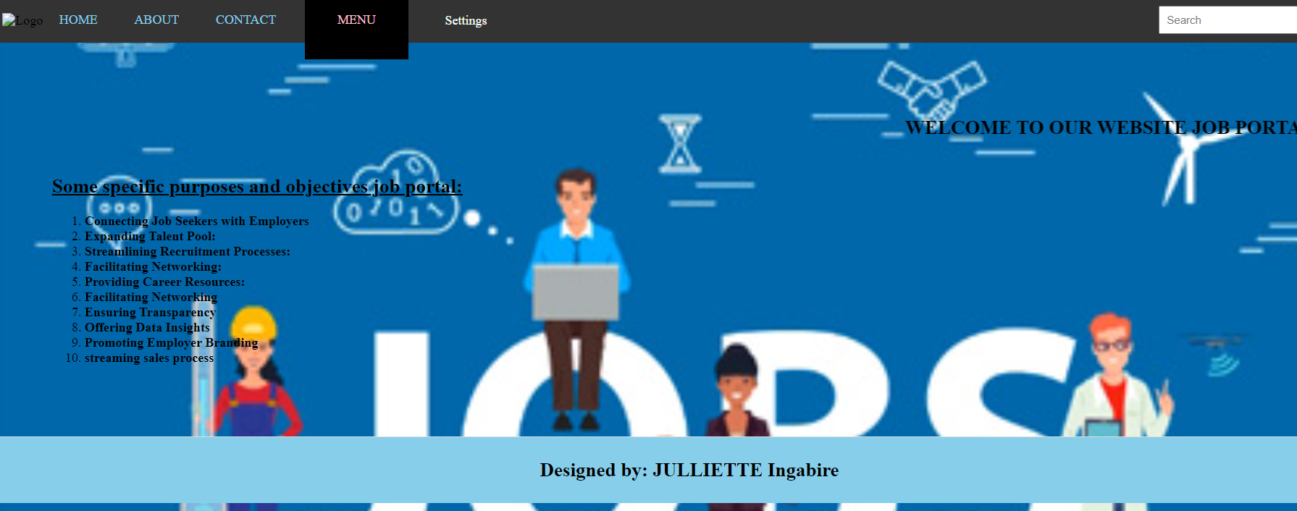

**Application table**

In all tables you have to update or delete information thatb what

Examples .

When you click on button you see “are you sure you want to update” if you want you click if you does not want you cancel.

 if you want to delete table you click 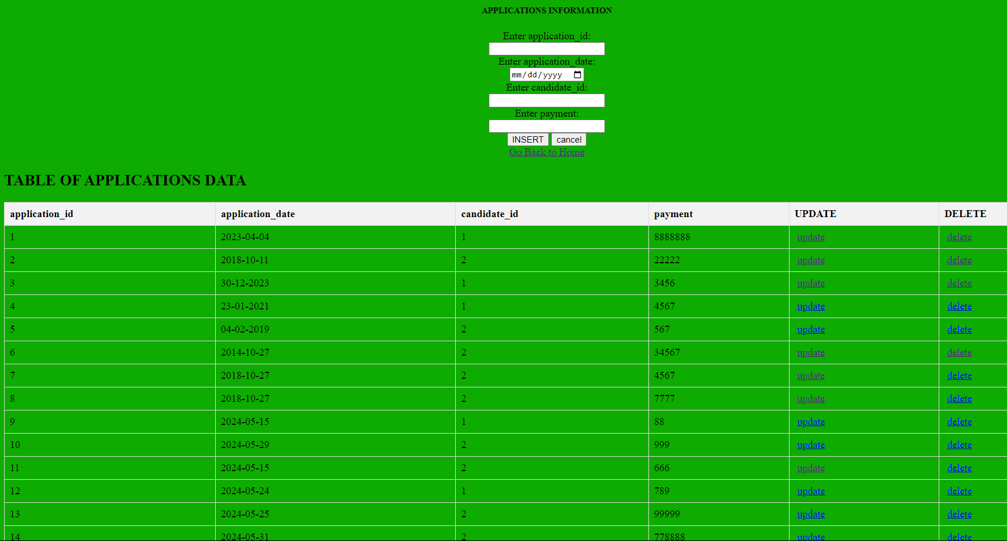

**Candidates table** 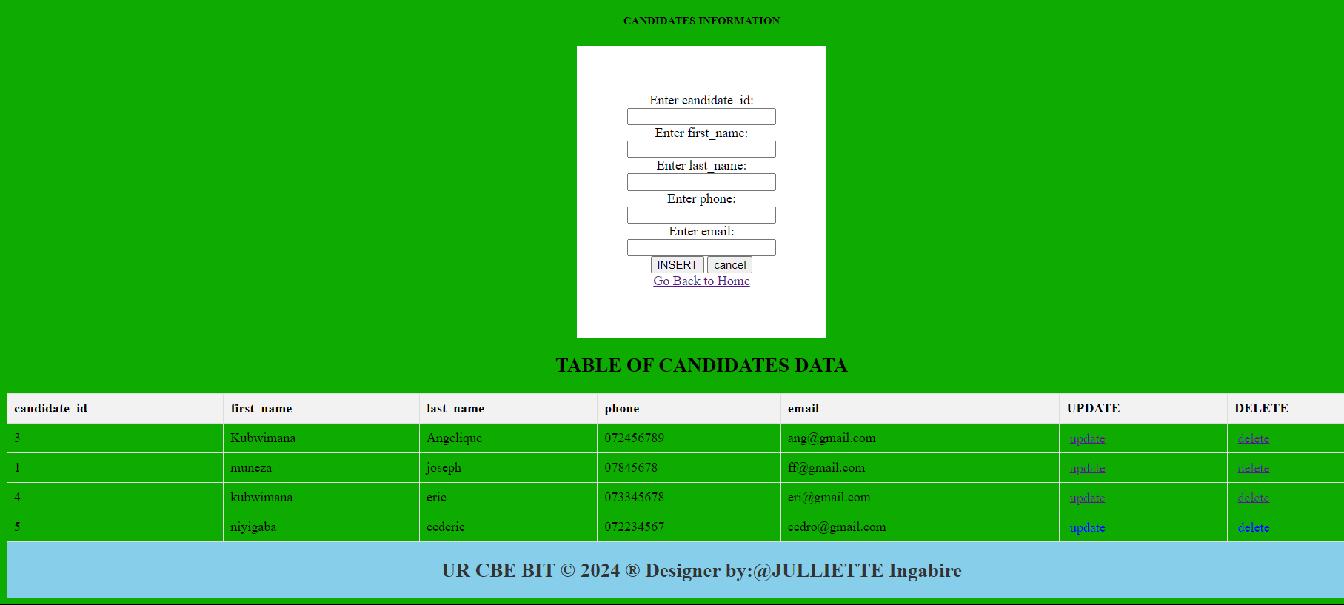

**Jobs table** 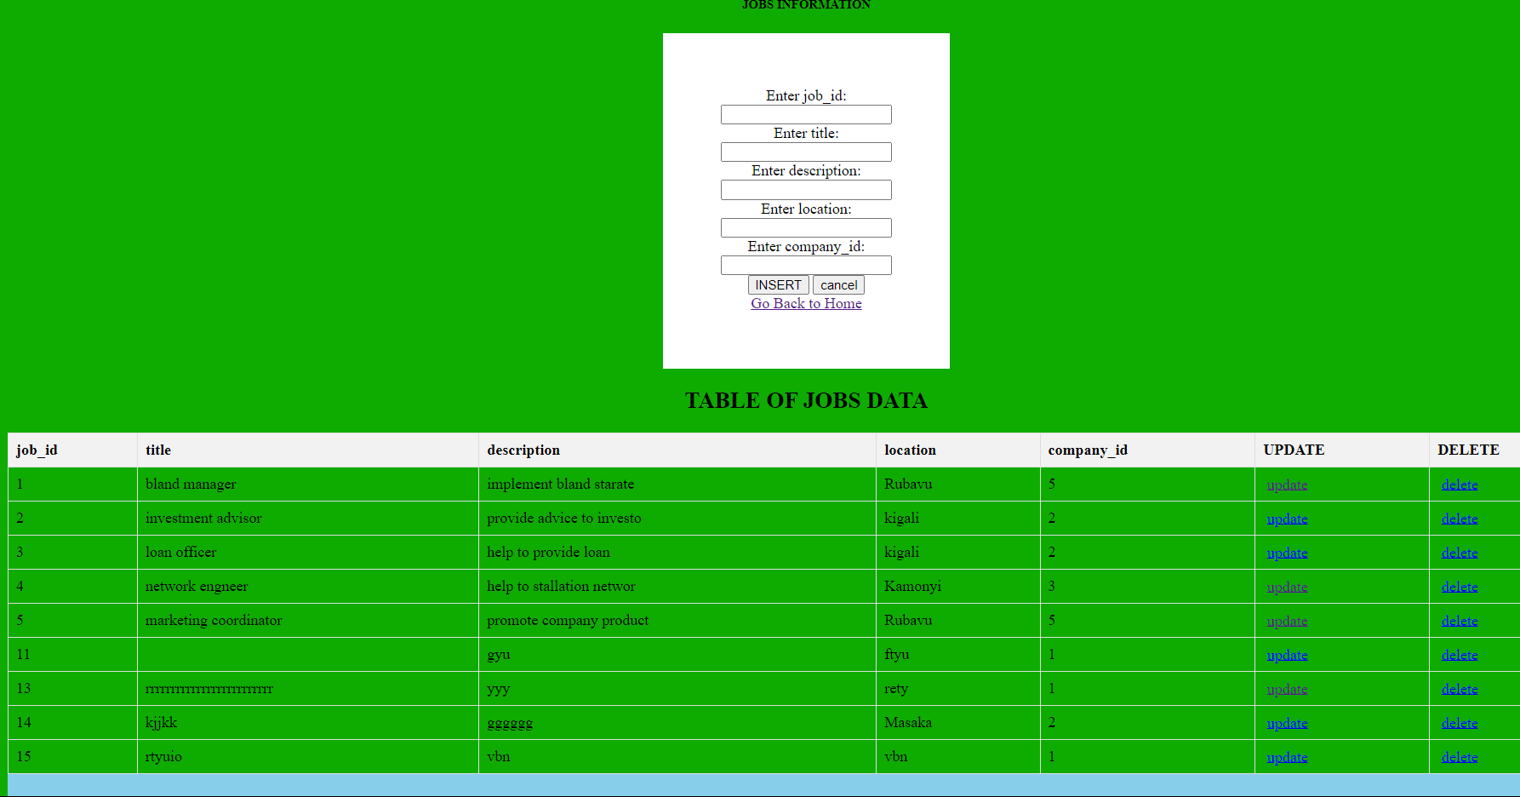

Experience table 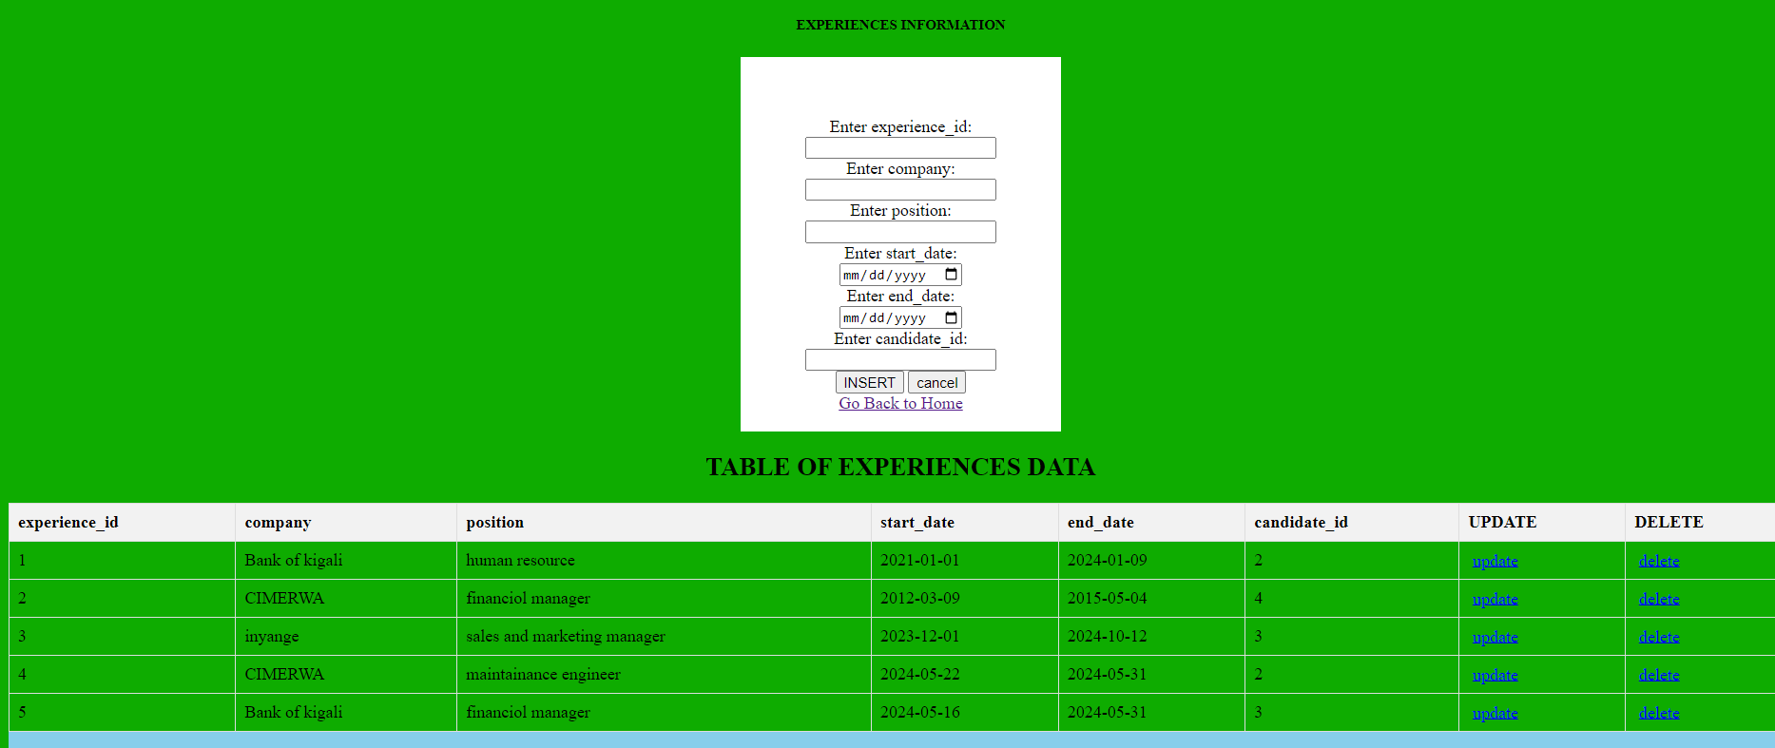

Educations table 